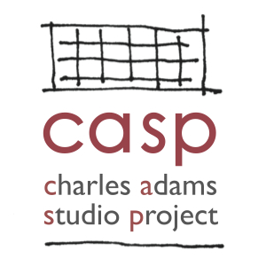
Charles Adams Studio Project (CASP)
2021 Helen DeVitt Jones Print Studio Fellowship Application

Personal Information
Full Name: _______________________________________ Phone: _______________________________________

Current Address: _______________________________________________________________________________

Mailing Address (if different from above): ___________________________________________________________

Email: ________________________________________________________________________________________

Emergency Contact Name: __________________________ Emergency Contact Phone: ______________________

Emergency Contact Relationship to Applicant:

Educational Background
Level of Education | Name & Address of School | Major | Degree Earned
High School
College
Graduate School

Are you currently enrolled in school? ___________________ If yes, where? ________________________________

If yes, are you enrolled full-time or part-time? ________________________________________________________

Will you be using the fellowship to meet an internship or other credit requirement for your degree program?

Weekly availability (Please list preferred days and times. Some Saturday availability preferred.):

_____________________________________________________________________________________________

Date Available to Start: __________________________________________________________________________

Relevant Skills
Check all those that apply
Top of Form
Screen Printing
Letterpress
Etching
Lithography
Other

Relevant Employment / Internship / Volunteer History
Please list up to four most recent AND relevant positions
Employer | Position Title | Description of Duties | Dates of Employment | Supervisor Contact

Bottom of Form

References
Professional Reference 1
Name: _________________________________ Phone: ___________________________

Email: _________________________________ Position/Title:___________________________________________

Relationship to Reference: ____________________________ Years Known: _______________________________

Professional Reference 2
Name: _________________________________ Phone: ___________________________

Email: _________________________________ Position/Title:___________________________________________

Relationship to Reference: ____________________________ Years Known: _______________________________

Personal Reference 1
Name: _________________________________ Phone: ___________________________

Email: _________________________________ Position/Title:___________________________________________

Relationship to Reference: ____________________________ Years Known: _______________________________

Personal Response
Please attach on a separate sheet

What do you think you can bring to CASP? (150 words or less)

What do you hope to gain from working as a Fellow at CASP? (150 words or less)

I, the undersigned, affirm that all of the information provided above is true.

Signature Date

Application Instructions

- Include
- Completed application
- Current resume or CV
- Up to 10 images of completed screen printing/lithography/etching/letterpress projects

- Title each file and include your first and last names in the title (e.g. “Jane Jones CV.pdf”).
- Upload your application, resume and images via Dropbox by copying and pasting the following link into your browser:
https://www.dropbox.com/request/PFmMFhz9Kg4WQlbSrOkl
You do not need a Dropbox account to submit your work to Dropbox.

