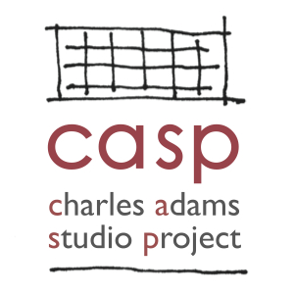
Charles Adams Studio Project (CASP)
2022 CH Foundation Metals Studio & Foundry Fellowship Application

Personal Information
Full Name: _______________________________________ Phone: _______________________________________

Current Address: _______________________________________________________________________________

Mailing Address (if different from above): ___________________________________________________________

Email: ________________________________________________________________________________________

Emergency Contact Name: __________________________ Emergency Contact Phone: ______________________

Emergency Contact Relationship to Applicant:

Educational Background
Level of Education | Name & Address of School | Major | Degree Earned
High School
College
Graduate School

Are you currently enrolled in school? ___________________ If yes, where? ________________________________

If yes, are you enrolled full-time or part-time? ________________________________________________________

Will you be using the fellowship to meet an internship or other credit requirement for your degree program?

Weekly availability (Please list preferred days and times. Saturday availability preferred.):

_____________________________________________________________________________________________

Date Available to Start: __________________________________________________________________________

Relevant Skills
Check all that apply
MIG welding
TIG welding
Oxygen/acetylene welding and cutting
Plasma cutting
Grinders, Benders, and Rollers
Foundry operations
Other:
Relevant Employment / Internship / Volunteer History
Please list up to four most recent AND relevant positions
Employer | Position Title | Description of Duties | Dates of Employment | Supervisor Contact

Bottom of Form

References
Professional Reference 1
Name: _________________________________ Phone: ___________________________

Email: _________________________________ Position/Title:___________________________________________

Relationship to Reference: ____________________________ Years Known: _______________________________

Professional Reference 2
Name: _________________________________ Phone: ___________________________

Email: _________________________________ Position/Title:___________________________________________

Relationship to Reference: ____________________________ Years Known: _______________________________

Personal Reference 1
Name: _________________________________ Phone: ___________________________

Email: _________________________________ Position/Title:___________________________________________

Relationship to Reference: ____________________________ Years Known: _______________________________

Personal Response
Please attach on a separate sheet

What do you think you can bring to CASP? (150 words or less)

What do you hope to gain from working as a Fellow at CASP? (150 words or less)

I, the undersigned, affirm that all the information provided above is true.

Signature Date

Application Instructions

- Include
- Completed application
- Current resumé or CV
- Up to 10 images of completed foundry/casting/metalwork/woodworking projects

- Title each file and include your first and last names in the title (e.g. “Jane Jones CV.pdf”).
- Upload your application, resume and images via Dropbox by copying and pasting the following link into your browser:
https://www.dropbox.com/request/JWvf5JPGKZVn5JfGOayx
You do not need a Dropbox account to submit your work to Dropbox.

