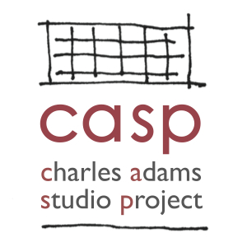
Charles Adams Studio Project (CASP)
2023 Arts Administration Fellowship Application

Personal Information

Full Name: _______________________________________ Phone: _______________________________________

Current Address: _______________________________________________________________________________

Mailing Address (if different from above): ___________________________________________________________

Email: ________________________________________________________________________________________

Emergency Contact Name: __________________________ Emergency Contact Phone: ______________________

Emergency Contact Relationship to Applicant:

Educational Background
Level of Education | Name & Address of School | Major | Degree Earned
High School
College
Graduate School

Are you currently enrolled in school? ___________________ If yes, where? ________________________________

If yes, are you enrolled full-time or part-time? ________________________________________________________

Will you be using the fellowship to meet an internship or other credit requirement for your degree program?

Weekly availability (up to 20 hours per week, please list preferred days and times):

_____________________________________________________________________________________________

Date Available to Start: __________________________________________________________________________

Relevant Skills
Check all those that apply
Grant Writing QuickBooks
Marketing Adobe Acrobat
Social Media Word Press Websites
Microsoft Word Other:
Microsoft Excel
Microsoft PowerPoint
Relevant Employment / Internship / Volunteer History
Please list up to four most recent AND relevant positions
Employer | Position Title | Description of Duties | Dates of Employment | Supervisor Contact

Bottom of Form

References
Professional Reference 1
Name: _________________________________ Phone: ___________________________

Email: _________________________________ Position/Title:___________________________________________

Relationship to Reference: ____________________________ Years Known: _______________________________

Professional Reference 2
Name: _________________________________ Phone: ___________________________

Email: _________________________________ Position/Title:___________________________________________

Relationship to Reference: ____________________________ Years Known: _______________________________

Personal Reference 1
Name: _________________________________ Phone: ___________________________

Email: _________________________________ Position/Title:___________________________________________

Relationship to Reference: ____________________________ Years Known: _______________________________

Personal Response
Please attach on a separate sheet

Why are you interested in the CASP Arts Administration Fellowship? (150 words or less)

I, the undersigned, affirm that all the information provided above is true.

Signature Date

Application Instructions

- Include
- Completed application
- Current resumé or CV,
- 3-5 page writing sample

- Title each file and include your first and last names in the title (e.g. “Jane Jones CV.pdf”).
- Upload your application, resume and writing sample via Dropbox by copying and pasting the following link into your browser:
https://www.dropbox.com/request/YxcwZUJDT7Q7JBpk2XK4
You do not need a Dropbox account to submit your work to Dropbox.

